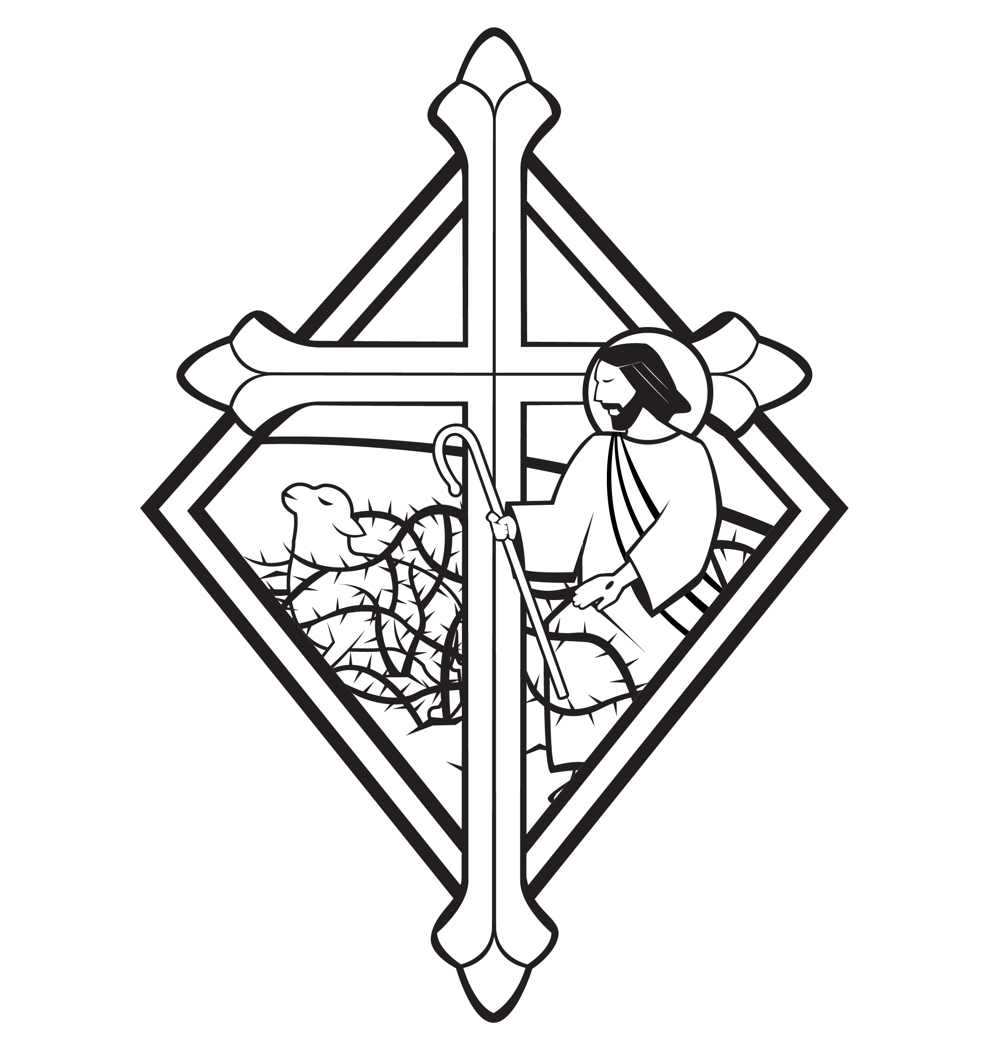
5th Sunday after Pentecost

CHRIST LUTHERAN CHURCH | Lodi, California
July 2, 2023

WELCOME TO WORSHIP
Welcome to Christ Lutheran Church. We pray that your soul will be strengthened by the good news about God’s grace, love, and forgiveness given to us. If you would like to learn more about our church, please speak with our pastor or one of our members after the service.
- Bathrooms are located in the fellowship hall. A changing table is located in the women’s bathroom.
WORSHIP THEME
When Jesus saw the crowds, he observed: “The harvest is plentiful, but the workers are few.” But what does he send the workers out to do? To gather people in to hear the gospel and be set free from the powers of sin, death, and devil. The Law of Moses from Mount Sinai could do nothing to reconcile sinners to God. Only the gospel of free grace and full forgiveness can save us. Today we pray that God will continue to send out workers into the harvest field to make known his salvation to the ends of the earth.
The Common Service
The high and holy worship of God is faith in Jesus Christ. Such faith is created and sustained by God’s service to us (the German, “Gottesdienst,” “The Divine Service”).
In the Divine Service, the Lord comes to us in His Word and Sacrament to bless and enliven us with His gifts. The Service is not something we do for God, but His service to us received in faith. The liturgy is God’s work. He gives, we receive.
HYMN God Has Spoken By His Prophets | CW 281

INVOCATION
M: In the name of the Father, and of the Son ✙ and of the Holy Spirit
C: Amen.
From God’s Word we know that wherever God puts His name, there He is to bless. In the Old Testament the temple was the place where God graciously caused His name to be present (1 Kings 8:27-30).
God has put His name —Father, Son, and Holy Spirit—on us in Holy Baptism. The Divine Service begins with the Invocation, the words spoken over us at our baptisms. Every Divine Service is for the hallowing of the Lord’s name, which the Small Catechism reminds us is done “when the Word of God is taught in its truth and purity, and we, as the children of God, also lead holy lives according to it” (Matthew 28:18-20).
CONFESSION
M: Beloved in the Lord: let us draw near with a true heart and confess our sins to God our Father, asking him in the name of our Lord Jesus Christ to grant us forgiveness.
C: Holy and merciful Father, I confess that I am by nature sinful, and that I have disobeyed you in my thoughts, words, and actions. I have done what is evil and failed to do what is good. For this I deserve your punishment both now and in eternity. But I am truly sorry for my sins, and trusting in my Savior Jesus Christ, I pray: Lord, have mercy on me, a sinner.
Lord, have mercy on us. Christ, have mercy on us. Lord, have mercy on us.

absolution
M: God, our heavenly Father, has been merciful to us and has given his only Son to be the atoning sacrifice for our sins. Therefore, as a called servant of Christ and by his authority, I forgive you all your sins in the name of the Father and of the Son ✙ and of the Holy Spirit.
C: Amen
M: In the peace of forgiveness, let us praise the Lord.
C: Glory be to God on high,
and on earth peace, good will toward men.
We praise you, we bless you, we worship you,
We glorify you, we give thanks to you, for your great glory.
O Lord God, heavenly King, God the Father almighty.
O Lord, the only begotten Son, Jesus Christ;
O Lord God, Lamb of God, Son of the Father,

You take away the sin of the world; have mercy on us.
You take away the sin of the world; receive our prayer.
You sit at the right hand of God the Father; have mercy on us.
For you only are holy; you only are the Lord.
You only, O Christ, with the Holy Spirit,
Are most high in the glory of God the Father. Amen.
PRAYER OF THE DAY
M: The Lord be with you.
C: And also with you.
M: Let us pray.
O God, protector of all the faithful, you alone make strong; you alone make holy. Show us your mercy and forgive our sins day by day. Guide us through our earthly lives that we do not lose the things you have prepared for us in heaven; through Jesus Christ our Lord, who lives and reigns with you and the Holy Spirit, one God, now and forever.
C: Amen
FIRST LESSON Exodus 19:2–8
Moses was God’s servant to set his people free from slavery in Egypt and provide them with his Word on Mount Sinai. But Moses’ deliverance and the instruction of the Law are a mere shadow of what Jesus has done for all people.
² After they set out from Rephidim, they entered the Desert of Sinai, and Israel camped there in the desert in front of the mountain.
³ Then Moses went up to God, and the Lord called to him from the mountain and said, “This is what you are to say to the descendants of Jacob and what you are to tell the people of Israel: ⁴ ‘You yourselves have seen what I did to Egypt, and how I carried you on eagles’ wings and brought you to myself. ⁵ Now if you obey me fully and keep my covenant, then out of all nations you will be my treasured possession. Although the whole earth is mine, ⁶ you^{[a]} will be for me a kingdom of priests and a holy nation.’ These are the words you are to speak to the Israelites.”
⁷ So Moses went back and summoned the elders of the people and set before them all the words the Lord had commanded him to speak. ⁸ The people all responded together, “We will do everything the Lord has said.” So Moses brought their answer back to the Lord.

PSALM Psalm 100, page 104
SECOND LESSON Romans 5:6–11
Once we were God’s enemies. But by God’s grace and the life, death, and resurrection of Christ we have been brought into the family and people of God.
⁶ You see, at just the right time, when we were still powerless, Christ died for the ungodly. ⁷ Very rarely will anyone die for a righteous person, though for a good person someone might possibly dare to die. ⁸ But God demonstrates his own love for us in this: While we were still sinners, Christ died for us.
⁹ Since we have now been justified by his blood, how much more shall we be saved from God’s wrath through him! ¹⁰ For if, while we were God’s enemies, we were reconciled to him through the death of his Son, how much more, having been reconciled, shall we be saved through his life! ¹¹ Not only is this so, but we also boast in God through our Lord Jesus Christ, through whom we have now received reconciliation.
VERSE OF THE DAY Psalm 132:9
Alleluia. May your priests be clothed with righteousness; may your saints sing for joy. Alleluia.
THE GOSPEL Matthew 9:35–10:8
Jesus tells his disciples to pray for workers to evangelize the plentiful harvest of sinners in need of forgiveness. Then he immediately answers that prayer by sending out his Apostles to proclaim the Kingdom of Heaven.
³⁵ Jesus went through all the towns and villages, teaching in their synagogues, proclaiming the good news of the kingdom and healing every disease and sickness. ³⁶ When he saw the crowds, he had compassion on them, because they were harassed and helpless, like sheep without a shepherd. ³⁷ Then he said to his disciples, “The harvest is plentiful but the workers are few. ³⁸ Ask the Lord of the harvest, therefore, to send out workers into his harvest field.”
10 Jesus called his twelve disciples to him and gave them authority to drive out impure spirits and to heal every disease and sickness.
² These are the names of the twelve apostles: first, Simon (who is called Peter) and his brother Andrew; James son of Zebedee, and his brother John; ³ Philip and Bartholomew; Thomas and Matthew the tax collector; James son of Alphaeus, and Thaddaeus; ⁴ Simon the Zealot and Judas Iscariot, who betrayed him.

⁵ These twelve Jesus sent out with the following instructions: “Do not go among the Gentiles or enter any town of the Samaritans. ⁶ Go rather to the lost sheep of Israel. ⁷ As you go, proclaim this message: ‘The kingdom of heaven has come near.’ ⁸ Heal the sick, raise the dead, cleanse those who have leprosy, drive out demons. Freely you have received; freely give.

M This is the Gospel of the Lord.
C: Praise be to you, O Christ!

NICENE CREED
We believe in one God, Dt. 6:4
the Father, the Almighty, 2 Cor. 6:18
maker of heaven and earth, Is. 51:13
The Nicene Creed is the great Confession of the Christian faith professed by all Christians. The Creed originated at the First Council of Nicaea (c. AD. 325)
of all that is, seen and unseen. Col. 1:16
We believe in one Lord, Jesus Christ, 1 Cor 8:6
the only Son of God, Jn. 3:16
eternally begotten of the Father, Heb. 1:2,5
God from God, Light from Light, true God from true God, Jn. 1
begotten, not made, of one being with the Father. Jn. 10:30
Through him all things were made. Jn. 1:3
For us and for our salvation, 1 Th. 5:9
he came down from heaven, Jn. 6:38
was incarnate of the Holy Spirit and the virgin Mary, Lk. 1:35
The Creed itself was crafted as a confession of Scripture in opposition to the Arian heresy, which denied that the Lord Jesus and the Holy Spirit are God.

and became fully human. Gal. 4:4
For our sake he was crucified under Pontius Pilate. Mk. 15:15
He suffered death and was buried. 1 Cor. 15:3-4a
On the third day he rose again in accordance
with the Scriptures. 1 Cor. 15:4b
He ascended into heaven Ac. 2:33-34
and is seated at the right hand of the Father. Heb. 1:13
He will come again in glory Mt. 25:31
to judge the living and the dead, 2 Tim. 4:1
and his kingdom will have no end. Lk. 1:33

We believe in the Holy Spirit, the Lord, the giver of life, Job 33:4
who proceeds from the Father and the Son, Jn. 15:26
who in unity with the Father and the Son Jn. 4:24
is worshiped and glorified,
who has spoken through the prophets. 2 Pet. 1:25
We believe in one holy Christian Mt. 16:18; Eph. 2:19-20
and apostolic Church.
We acknowledge one baptism for the forgiveness of sins. Eph. 4:5; Ac. 2:38
We look for the resurrection of the dead 1 Cor. 15:21-22
and the life of the world to come. Amen. Rev. 22
HYMN OF THE DAY God of the Prophets| CW 543
SERMON Exodus 19

OFFERING
In response to God’s love and forgiveness, we give back a portion of what he has given us. The members of Christ Lutheran Church have joined to proclaim the gospel to this community. These offerings support that work. While our guests are welcome to participate, they should not feel obligated to do so.
PRAYER OF THE CHURCH
M: Eternal God and Father, we give you thanks for the blessings we share as members of your holy Church, for your Word and Sacraments, for opportunities to serve others, for fellowship with Christians in our congregation and throughout the world. On the anniversary of our nation’s founding, we also praise and thank you for your grace upon your people within our nation: for the freedom to worship you without fear and to share the gospel of your salvation in the open.
C: Help us always to rejoice in these blessings, dear Lord, and to use them faithfully.

M: Raise up for us honest, wise, courageous and just leaders. Protect those who protect our nation and our communities. Give us and all citizens a willingness to obey our nation’s laws and to work for the common good. Provide us with daily bread and preserve us from all calamity according to your grace.
C: Teach us not to worry, but to cast all our cares on you.
M: Jesus Christ, Lord of the Church, you give grace to your people by calling us to be your witnesses in the world. Open our eyes to see the noble mission you have placed before us. In the hurting eyes of the lonely, in the pained eyes of the sick, and in the searching eyes of the lost, help us to see your face, O Jesus, and to serve others as we would serve you.
C: Through our lives, make your light shine.
M: Holy Spirit, giver of life, through Word and Sacrament bestow on us the wisdom and power we need to witness clearly and to act boldly. Help us to speak the truth in love, to give the reason for the hope we have, and to conduct ourselves with gentleness and respect.
C: Set our hearts on fire as we work and witness for Christ.
M: Hear our prayers for those we know who do not know you, or whose faith is weak or troubled.
Silent prayer
M: Bless the Church with men and women who are willing to proclaim your Word in places where we cannot go. Keep them and their loved ones in your care, and let nothing hinder their work.
C: Move us to support them with our sincere prayers and generous offerings.
Silent prayer.
M: Savior of all, hear our prayer and help us in our mission; to the glory of your Holy Name.
LORD’S PRAYER Matthew 6:9-13; Luke 11:2-4
C: Our Father, who art in heaven, hallowed be thy name,
thy kingdom come, thy will be done on earth as it is in heaven.
Give us this day our daily bread; and forgive us our trespasses,
as we forgive those who trespass against us;
and lead us not into temptation, but deliver us from evil.
For thine is the kingdom and the power
and the glory forever and ever. Amen.
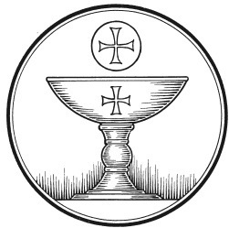
The Service of the Sacrament
This greeting marks a new service, so to speak. These ancient introductory words & phrases help to highlight, celebrate and bring attention to the Sacrament.
M: The Lord be with you.
C: And also with you.
M: Lift up your hearts.
C: We lift them up to the Lord.
M: Let us give thanks to the Lord our God.
C: It is good and right so to do.
M: It is truly good and right that we should at all times and in all places give you thanks, O Lord, holy Father, almighty and everlasting God, through Jesus Christ, our Lord, who promised that wherever two or three come together in his name, there he is with them to shepherd his flock till he comes again in glory. Therefore with all the saints on earth and hosts of heaven, we praise your holy name and join their glorious song:

HOLY, HOLY, HOLY – Sanctus
C: Holy, holy, holy Lord God of heavenly hosts:
heav’n and earth are full of your glory.
Hosanna, hosanna, hosanna in the highest!
Blessed is he, blessed is he, blessed is he who comes in the name of the Lord.
Hosanna, hosanna, hosanna in the highest.
WORDS OF INSTITUTION Matthew 26, Mark 14, Luke 22
M: Our Lord Jesus Christ, on the night he was betrayed, took bread; and when he had given thanks, he broke it and gave it to his disciples, saying: “Take and eat. This is my ✙ body, which is given for you. Do this in remembrance of me.”
The Words of institution both proclaim the words of Jesus to the congregation and sets apart the bread and wine for the Lord’s Supper.
Then he took the cup, gave thanks, and gave it to them, saying, “Drink from it all of you; this is my ✙ blood of the new covenant, which is poured out for you for the forgiveness of sins. Do this, whenever you drink it, in remembrance of me.”

PEACE OF THE LORD – Pax Domini John 20:19
M: The peace of the Lord be with you always.
C: Amen

O CHRIST, LAMB OF GOD – Agnus Dei John 1:29
C: O Christ, Lamb of God,
you take away the sin of the world;
have mercy on us.
O Christ, Lamb of God,
you take away the sin of the world;
have mercy on us.
O Christ, Lamb of God,
you take away the sin of the world;
Grant us your peace. Amen.

DISTRIBUTION
Those who will be receiving Holy Communion today may wish to read Personal Preparation for Holy Communion, found on page 156 in the front section of the hymnal. This page helps us put into practice what the Bible encourages: “Everyone ought to examine themselves before they eat of the bread and drink from the cup.” (1 Corinthians 11:28)
Christ Lutheran Church confesses and practices the Biblical teaching of a Closed Communion. We ask that only members of the Wisconsin Synod [WELS] or the Evangelical Lutheran Synod [ELS] join us at the Lord’s Table. If you have questions concerning our communion practice, or would like to inquire about how you, too, can commune with us, please speak with the Pastor following the service.
THE SONG OF SIMEON
C: Lord, now you let your servant, depart in peace
According to your word.
For my eyes have seen your salvation,
Which you have prepared before the face of all people,
A light to lighten the Gentiles
And the glory of your people Israel.

M: We give thanks, almighty God, that you have refreshed us with this holy supper. We pray that through it you will strengthen our faith in you and increase our love for one another. We ask this in the name of Jesus Christ, our Lord, who lives and reigns with you and the Holy Spirit, one God, now and forever.
C: Amen.

THE BLESSING
M: The Lord bless you and keep you.
The Lord make his face shine on you and be gracious to you.
The Lord look on you with favor and ✙ give you peace.
C: Amen.
CLOSING HYMN Hark the Voice of Jesus Crying | CW 573

COPYRIGHT INFORMATION
Content requiring a copyright license is reproduced under OneLicense.net #A-718312. All rights reserved. The Common Service: Texts revised from The Lutheran Hymnal, 1941. Music revised by James Engel. Scripture Quotations: From the Holy Bible, New International Version (NIV 1984), © 1973, 1978, 1984 by Biblica, Inc.

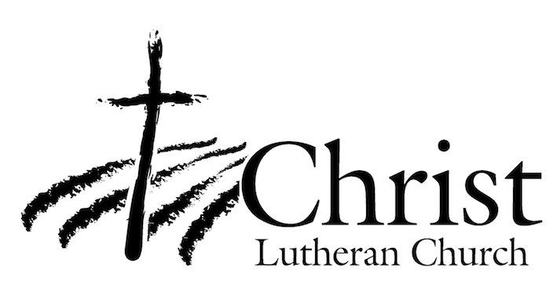
13009 N. Elderberry Ct.
Lodi, CA 95242
www.christlodi.org
209-368-6250
Pastor Tim Leistekow
WELCOME TO CHRIST EV. LUTHERAN CHURCH!
We preach a message of forgiveness, hope and peace
through the death and resurrection of Jesus Christ.
Families and individuals of all ages will find opportunities
both to grow and to serve.
Our mission statement:
Look what Christ is doing!
He binds us together in fellowship
He gathers us in for worship
He builds us up for service
He sends us out with the gospel

“Now you are the body of Christ,
and each one of you is a part of it.”
(1 Corinthians 12:27)

